1. Using Java API copy a file from HDFS to Local file system.

i)the file is checked whether being present in the HDFS:

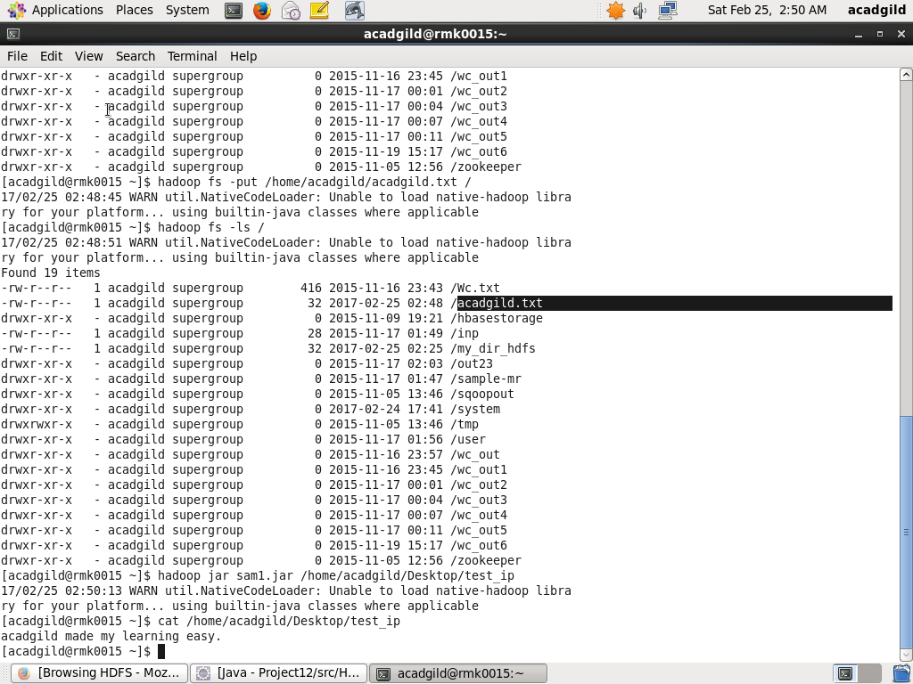

ii)The jar file is transferred to the desktop and contents of that file is checked:

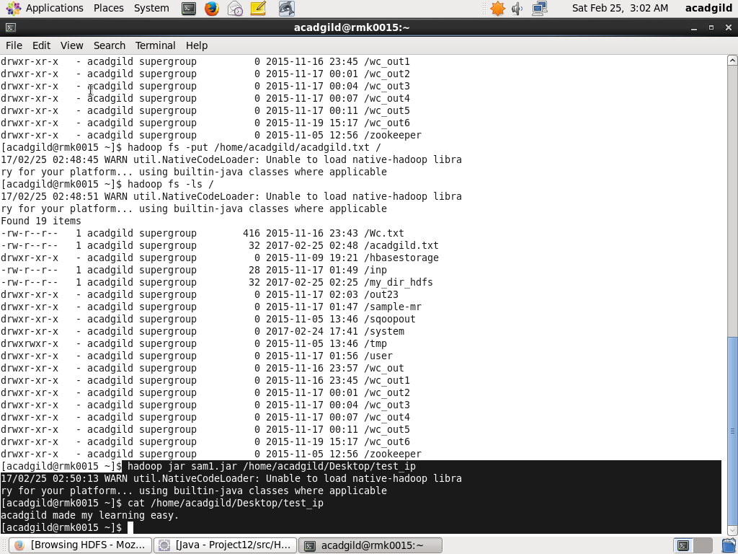

2.Using Java API copy a file from LFS to HDFS

i)It is checked whether the file is present in the local file system:

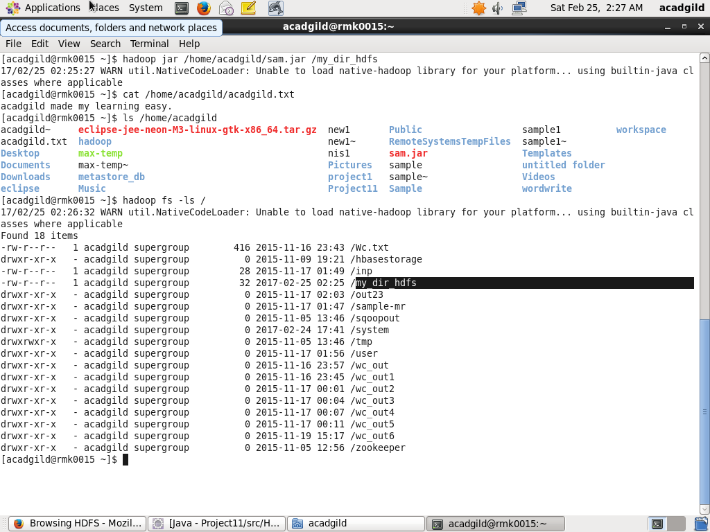

ii)The file is transferred from local file system to hdfs and contents of that file is retrieved:

